Outbound Traffic

⬆️ What Is Outbound Traffic in Networking?
# Source: AI Source: Provided by: [Data Path: Persons Table -> ID Column: 1, Name_En Column: Motasem Essam] -> From: [ChatGPT] on [12/9/2025]
Outbound traffic is all data that leaves your device, network, or server to an external destination. It refers to outgoing connections or data packets traveling from inside → out to the internet or another network.

📦 Belongs to:
# Source: AI Source: Provided by: [Data Path: Persons Table -> ID Column: 1, Name_En Column: Motasem Essam] -> From: [ChatGPT] on [12/9/2025]
✅ Network Traffic Direction
(paired with Inbound Traffic — the incoming flow)

📡 Examples of Outbound Traffic:
# Source: AI Source: Provided by: [Data Path: Persons Table -> ID Column: 1, Name_En Column: Motasem Essam] -> From: [ChatGPT] on [12/9/2025]
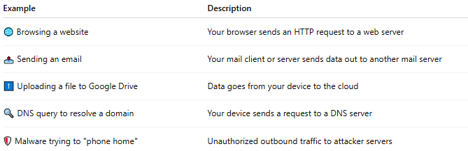

Example | Description
🌐 Browsing a website | Your browser sends an HTTP request to a web server
📤 Sending an email | Your mail client or server sends data out to another mail server
⬆️ Uploading a file to Google Drive | Data goes from your device to the cloud
🔍 DNS query to resolve a domain | Your device sends a request to a DNS server
🛡️ Malware trying to "phone home" | Unauthorized outbound traffic to attacker servers

🔐 Why Outbound Traffic Matters
# Source: AI Source: Provided by: [Data Path: Persons Table -> ID Column: 1, Name_En Column: Motasem Essam] -> From: [ChatGPT] on [12/9/2025]
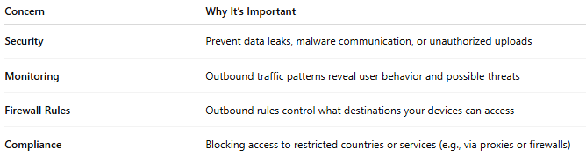

Concern | Why It’s Important
Security | Prevent data leaks, malware communication, or unauthorized uploads
Monitoring | Outbound traffic patterns reveal user behavior and possible threats
Firewall Rules | Outbound rules control what destinations your devices can access
Compliance | Blocking access to restricted countries or services (e.g., via proxies or firewalls)

🆚 Inbound vs Outbound Traffic
# Source: AI Source: Provided by: [Data Path: Persons Table -> ID Column: 1, Name_En Column: Motasem Essam] -> From: [ChatGPT] on [12/9/2025]
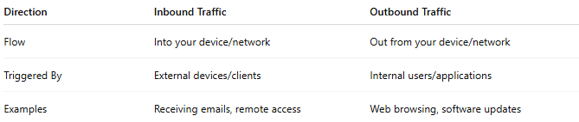

Direction | Inbound Traffic | Outbound Traffic
Flow | Into your device/network | Out from your device/network
Triggered By | External devices/clients | Internal users/applications
Examples | Receiving emails, remote access | Web browsing, software updates

📌 Summary
# Source: AI Source: Provided by: [Data Path: Persons Table -> ID Column: 1, Name_En Column: Motasem Essam] -> From: [ChatGPT] on [12/9/2025]
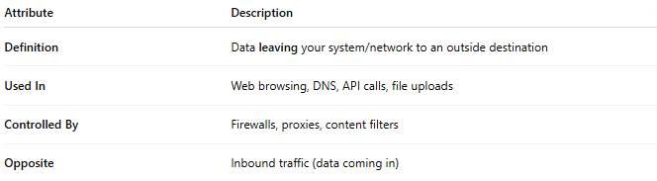

Attribute | Description
Definition | Data leaving your system/network to an outside destination
Used In | Web browsing, DNS, API calls, file uploads
Controlled By | Firewalls, proxies, content filters
Opposite | Inbound traffic (data coming in)

